

Assessment Cover Page

Student Full Name | Katlego Hazel Moses
Student Number | 2025127
Module Title | Machine Learning for Business & Data Visualization
Assessment Title | Intergrated CA2
Assessment Due Date | 07-12-25
Date of Submission | 07-12-25

Question One:
Recommendation Systems (RS):
Recommendation systems are crucial for online retail because they help customers discover products that match their interests, filtering through thousands of items to present the most relevant options (Ricci et al., 2015). By providing personalised suggestions, these systems increase sales, boost conversion rates, encourage repeat purchases, and support cross-selling and up-selling strategies, as seen with Amazon and Netflix (Amazon Science, 2023; Gómez-Uribe & Hunt, 2016). Machine learning underpins these systems, analysing historical interactions such as ratings, purchases, and clicks to detect complex patterns and continuously improve recommendations using algorithms like k-Nearest Neighbours, matrix factorisation, and neural networks (Aggarwal, 2021). Types of recommendation systems include content-based filtering, which matches items to user profiles based on attributes, and collaborative filtering, which relies on patterns among users or items. Overall, recommendation systems personalise the shopping experience, enhancing customer satisfaction, loyalty, and business growth (Zhang et al., 2019).
Market Basket Analysis (MBA):
Market Basket Analysis is a technique used in retail to understand which products customers tend to buy together. By analysing past transactions, MBA helps identify natural buying patterns such as combinations of items that commonly appear in the same basket. These insights allow businesses to design more effective promotions, place related products closer together in stores, recommend bundles online, and manage inventory more efficiently (Han et al., 2018). For example, if customers who buy coffee often buy pastries, a retailer can offer discounts on the pair or ensure they are stocked and displayed together. Overall, MBA supports data-driven decisions that increase sales and improve customer experience.

In this project, three different datasets were used because each question required a different type of analysis, and not all datasets were suitable for every machine learning task:
The Anime dataset: was used to demonstrate content-based recommendation systems because it contains rich textual and descriptive features that help identify similarities between items. The dataset includes variables such as Name, Type, Rating, Rank, Description, Tags, and NTags, which describe the characteristics of each anime. These text-based and categorical attributes make the dataset suitable for building recommendations based on item similarity, such as matching a user’s favourite anime with others that share similar genres or themes. The dataset was sourced from an open repository that provides datasets for recommendation system research: https://www.juheapi.com/datasets/anime-recommendation-system?gtm_event=register_suc.
The Amazon (Beauty_Ratings) dataset was selected for collaborative filtering because it contains user-item interactions in the form of product ratings. It includes UserId, ProductId, Rating, and Timestamp, which are ideal for machine learning models that rely on numerical feedback to calculate similarities between users or items. This dataset supported the implementation of both user-user and item-item collaborative filtering, enabling the prediction of how a user might rate a product based on patterns learned from other users. It was also used to create an interactive dashboard using Streamlit, allowing older adults to explore product ratings in a user-friendly way. The dataset was obtained from a public data-sharing platform: https://www.opendatabay.com/data/consumer/3c341bc9-2f4f-4e39-b337-62bc1a4a1dee.
The Bakery dataset was chosen for Market Basket Analysis because it contains detailed information about customer transactions. Its features include TransactionNo, Items, DateTime, DayPart, and DayType, which provide the structure needed to analyse purchasing patterns. This dataset allowed the use of Apriori and FP-Growth algorithms to discover associations between items frequently bought together. It also served as the foundation for an interactive dashboard created with Dash, designed for adults aged 65+ to clearly explore popular products and peak purchasing periods. The dataset was downloaded from an online open data portal: https://www.opendatabay.com/data/consumer/5025cda7-1204-4ae1-a99f-53967a90c93c.

Content Based Filtering (CBF) – {Using the Anime Dataset}
To implement content based filtering, I used the Anime dataset.
The goal of the following code is to recommend anime based on similarity in descriptions and tags. This works because content-based filtering looks at item features rather than user behaviour.
- Combining text features:
In thes step, I am creating a single test column by merging thw anime description with its tags. This will give the model more information to understand what each anime is about.

- Creating a recommendation function:
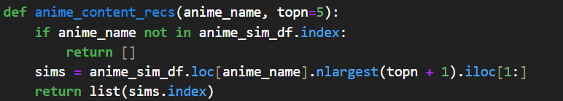
This function checks if the anime is in the dataset and also finds the most similar titles. On top of that, it shows the top five recommendations, ignoring the anime itself because its similarity to itself will always be 1.

- Testing:
This code asks the content based recommendation function to find 5 anime titles that are most similar to “Naruto” based on their descriptions and tags.

These results show the top 5 anime with the highest similarity to “Naruto”. Also, all recommended titles are part of the Naruto movie or sequel series which makes sense because the descriptions and tags share themes that are similar; for example; ninja, action, adventure etc.
In conclusion, the model correctly recommends anime that belong to the same “universe” as Naruto because the textual content is very similar.

Collaborative Filtering (CF) – {Using the Amazon Dataset – ratings_Beauty}
Collaborative filtering is a recommendation technique that suggests products or items to a user based on past interactions of many users, rather than item features. It assumes that users who agreed in the past will also agree in the future. In other words, it finds patterns in user behaviour to predict what a user might like next (Aggarwal, 2021).
Significance in Online Retail
Collaborative filtering is widely used in e-commerce platforms like Amazon and Netflix because it can recommend personalized products without needing detailed information about the products themselves. It helps increase sales, customer engagement, and satisfaction (Schafer et al., 2015).
To implement collaborative filtering, I made use of the Amazon dataset;
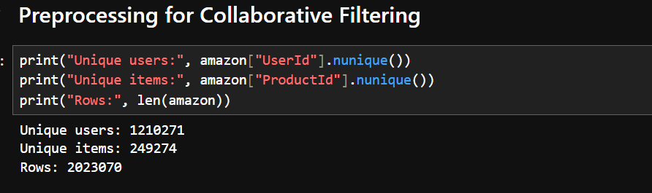
This code checks the size and scope of the dataset.
Results:
Unique users: 1210271 - Over 1.2 million customers provided ratings.
Unique items: 249274 - Around 250,000 products are rated.
Rows: 2023070 - Each row represents a single user rating a product.
The dataset is very large and sparse, meaning most users rate only a small fraction of all products.
User-User Collaborative Filtering
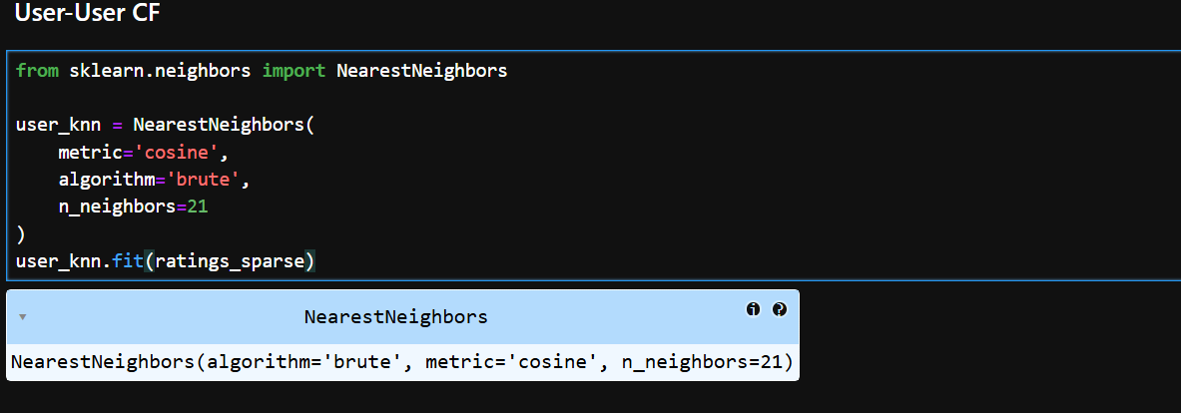
User-user collaborative filtering was used to find people who rate products in a similar way. The idea is that if two users have shown similar rating patterns in the past, they will likely enjoy similar items in the future (Ricci et al., 2015). To do this, a K-Nearest Neighbours (KNN) model was trained on the user-item rating matrix created from the Amazon dataset.
User-User Collaborative Filtering Testing:
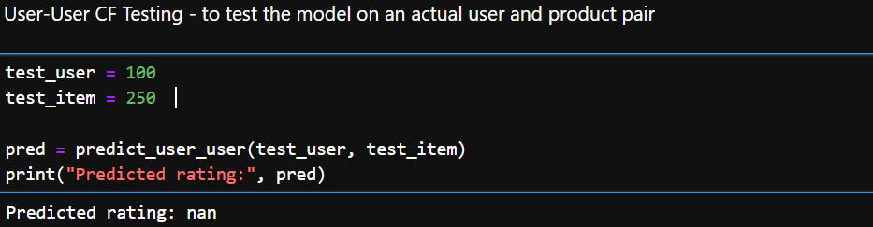
The output returned NaN, meaning the system could not generate a score. This normally happens when none of the user’s nearest neighbours has rated the chosen item, so there is no information available to make a prediction (Aggarwal, 2016). It is a common issue in large, sparse rating datasets like Amazon’s, where most users only rate a few products, leaving many user–item combinations without enough data for a collaborative filtering model to work.

Item-Item Collaborative Filtering
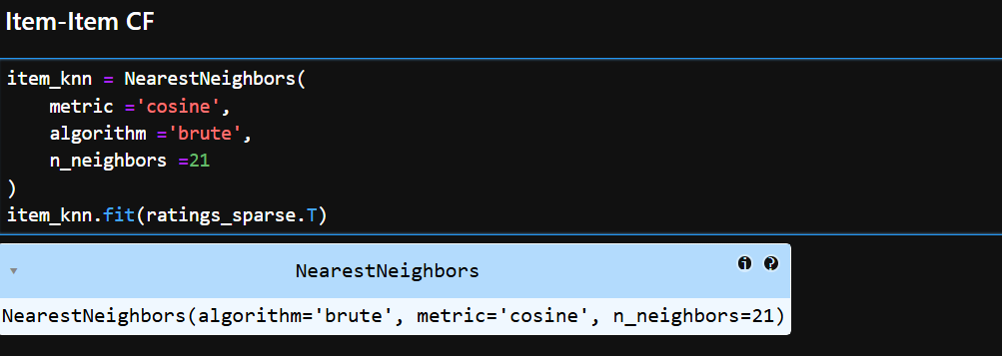
The Testing:
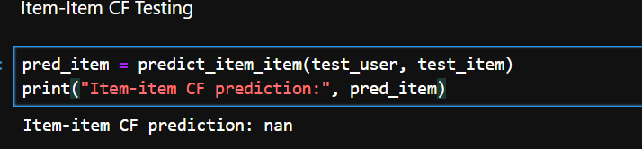
When testing the item-item model using the example user (test_user = 100) and item (test_item = 250), the prediction output was:
Item-item CF prediction: nan
This result usually means that the model did not have enough information to calculate a predicted rating.
Because item-item collaborative filtering relies on finding sufficiently similar products with overlapping user ratings, a lack of shared interactions leads to a missing prediction (NaN).
Content Based Filtering VS Collaborative Filtering
Content-Based Filtering and Collaborative Filtering are two major approaches used in online retail recommendation systems, but they work differently. CBF focuses on the properties of items, such as descriptions, tags, or product features, and matches them to what a user liked before. This means the system learns directly from the user’s own history and does not require data from other customers (Lops et al., 2011). CBF works well when item information is rich and consistent, and it avoids problems like cold-start for new users because it only needs the item attributes. However, it can become repetitive by recommending very similar items and may fail when item descriptions are missing or poor (Aggarwal, 2021).
Collaborative Filtering, on the other hand, does not look at item content. Instead, it uses patterns in user behaviour, such as ratings or purchases, to find similarities between users (user-user CF) or similarities between items (item-item CF) (Ricci et al., 2015). CF can produce more diverse recommendations because it learns from many people, and it often performs better when there is a large amount of user activity. But CF struggles with sparsity, cold-start, and scalability when datasets are extremely large, which is common in retail platforms like Amazon (Su & Khoshgoftaar, 2009).
In summary, CBF is strong when item descriptions are detailed, while CF is powerful when there is enough user behaviour data. Many online retailers combine both approaches to achieve more accurate and diverse recommendations.

Question 2: Market Basket Analysis (Bakery Dataset)
Market Basket Analysis is a method used to find products that customers often buy together. It is commonly used in supermarkets, e-commerce shops, cafés, and bakeries to understand buying behaviour and create useful strategies like product placement, bundles, and targeted promotions (Han, Pei & Kamber, 2018). MBA works by analysing transaction data and finding patterns in how items appear together.
Applying Apriori:
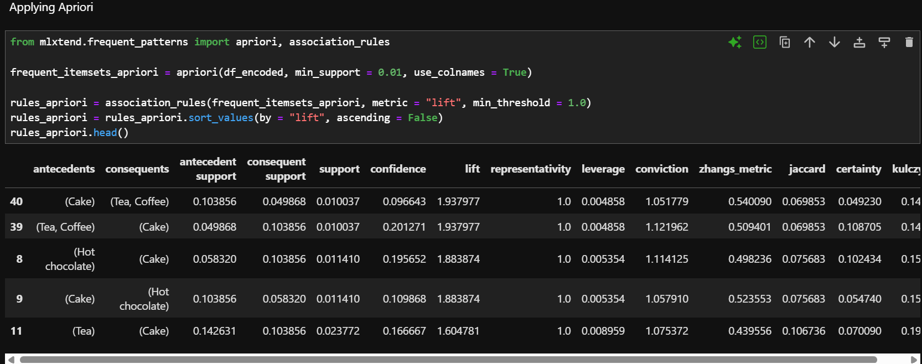
Applying FP-Growth:
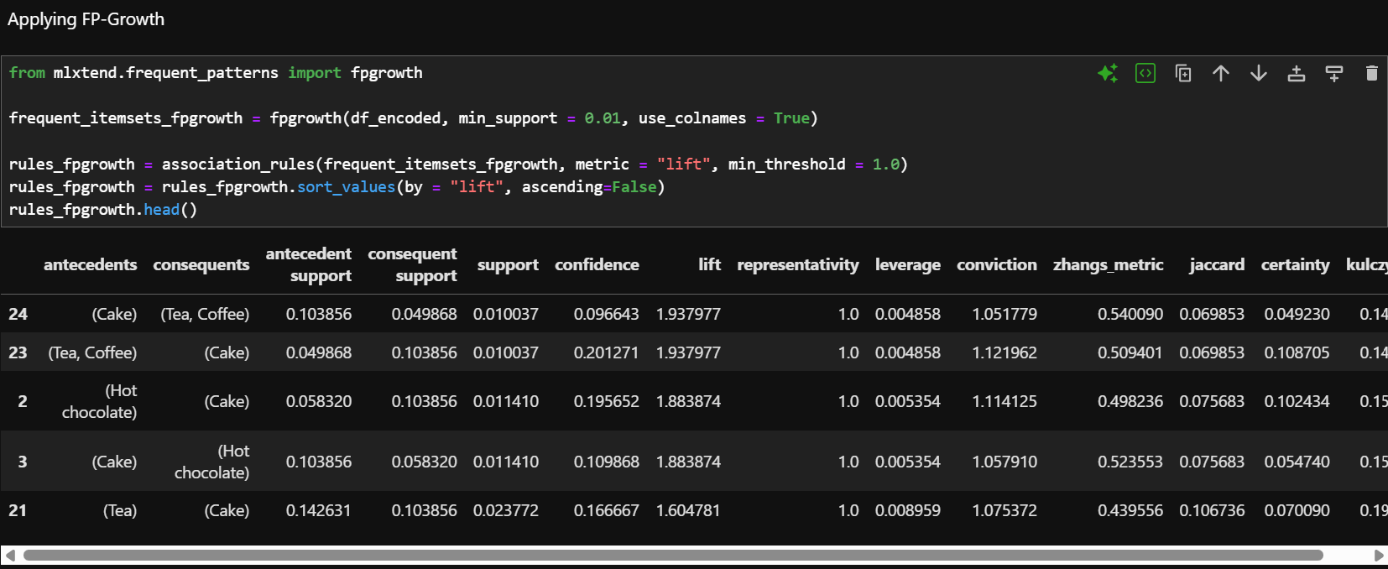

Apriori VS FP-Growth
Apriori and FP-Growth are two popular algorithms used for Market Basket Analysis to find frequent patterns in transaction data. Apriori works by generating candidate itemsets and scanning the dataset multiple times to check which combinations meet a minimum support threshold (Agrawal & Srikant, 1994). While it is simple and intuitive, it can be slow for large datasets because of the repeated scanning and candidate generation. FP-Growth, on the other hand, uses a compact data structure called an FP-tree to store the dataset and extract frequent patterns without generating candidates explicitly, making it faster and more efficient for large datasets (Han et al., 2000). Despite these differences, both algorithms often produce the same set of strong association rules, as seen in our bakery dataset results, where the top rules by lift were identical for both methods. In practical terms, Apriori may be easier to understand for beginners, while FP-Growth is preferred for scalability and speed in real-world retail applications.

Question 3: Interactive Dashboards
Ttwo interactive dashboards were developed to demonstrate the application of machine learning and data analysis in an online retail context, designed specifically for older adults (65+). The goal was to present key insights from the datasets in a clear, engaging, and easily interpretable way.
- Bakery Dashboard (Dash):

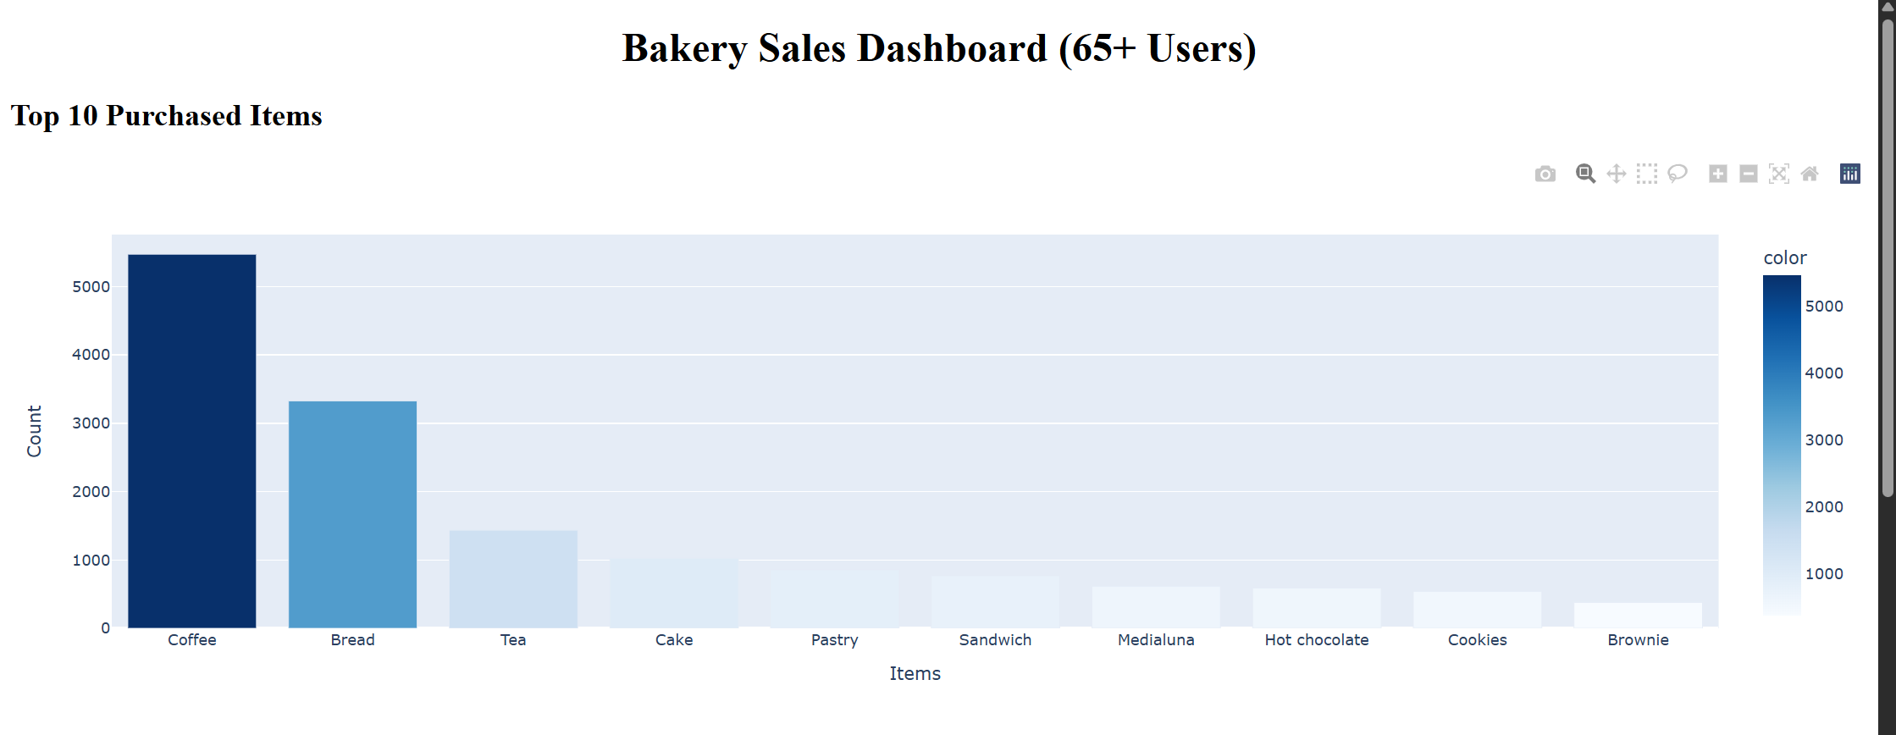

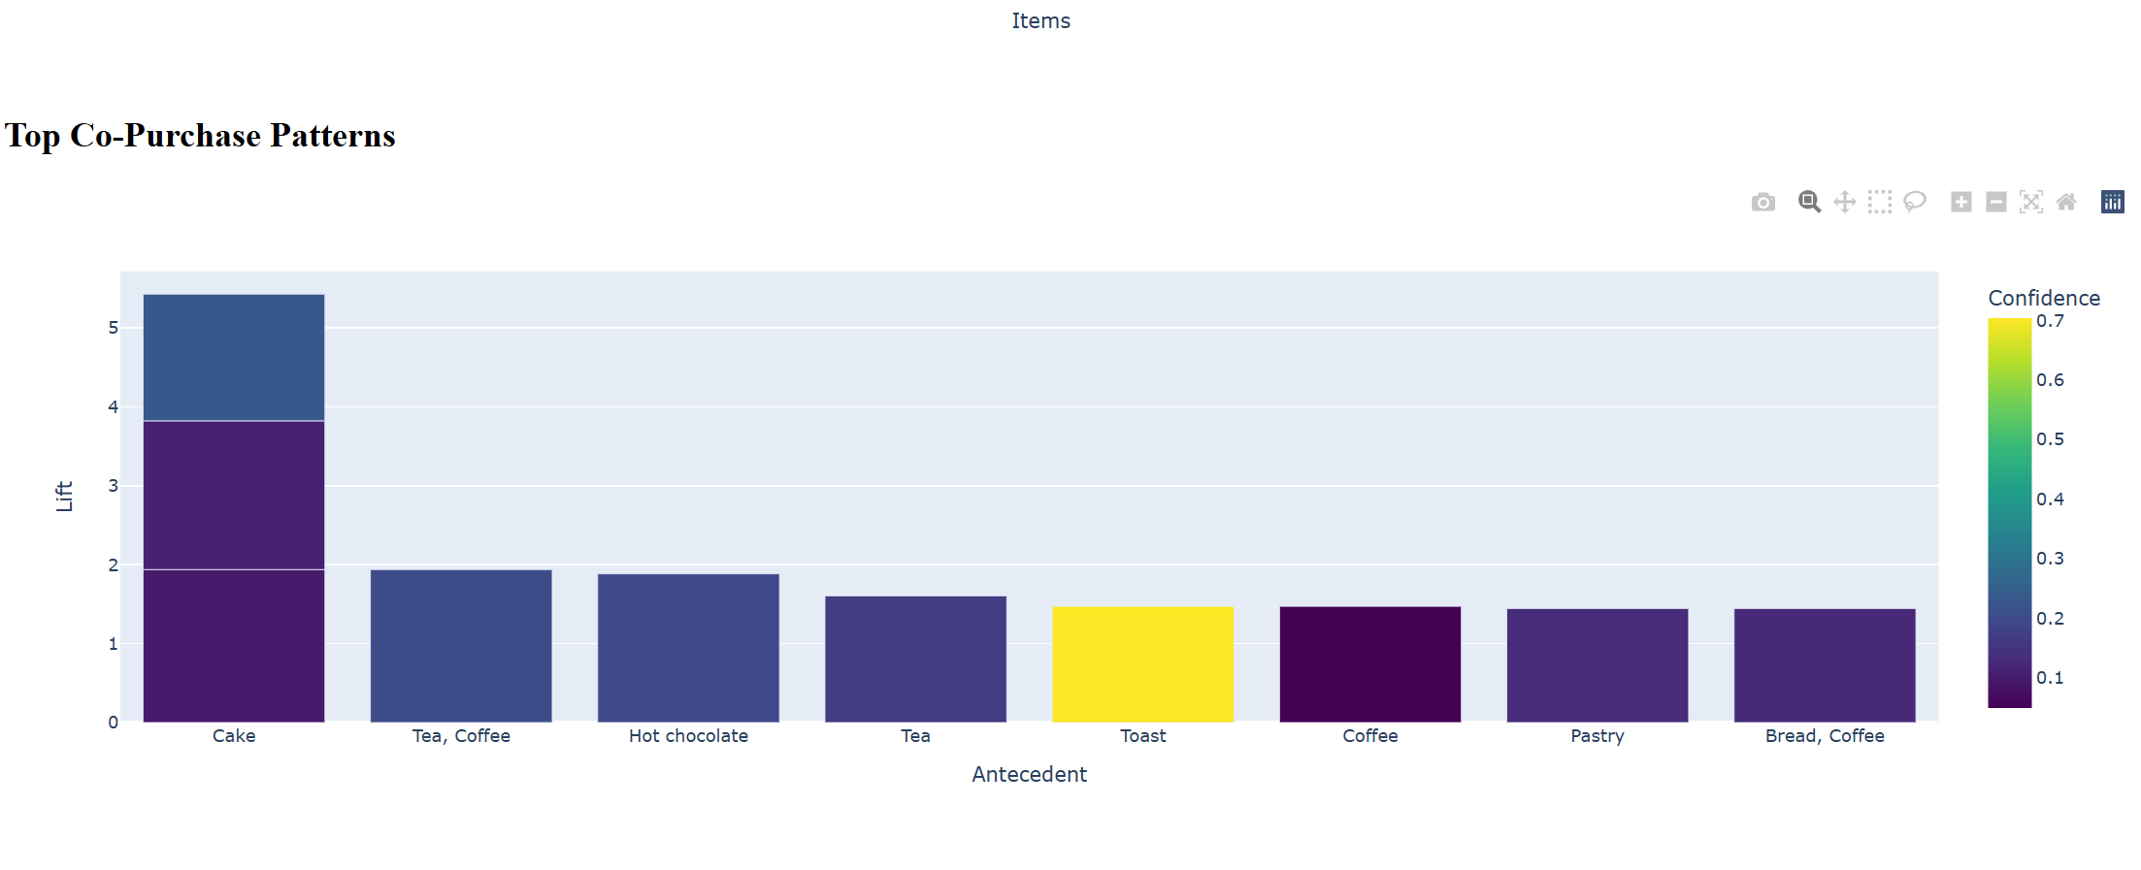

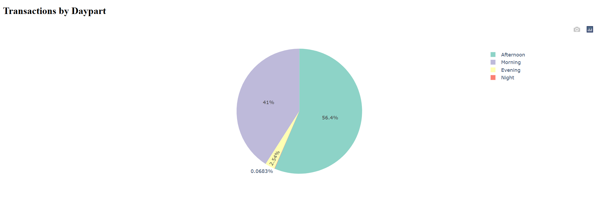
The Bakery dataset was used to create a dashboard using Dash, focusing on Market Basket Analysis results. The dashboard included:
- Top purchased items: A bar chart showing the 10 most frequently bought bakery products, helping older users quickly understand popular items.
- Top co-purchase patterns: A bar chart displaying product combinations derived from Apriori rules, showing items often bought together, which can inform cross-selling strategies.
- Transactions by daypart: A pie chart visualizing purchase distribution across different parts of the day, helping users identify peak shopping times.
The dashboard used large headings, high-contrast colors, and simple interactive charts to improve readability and usability for older adults, following principles of accessible design (Lazar et al., 2017).
- Amazon Dashboard (Streamlit):

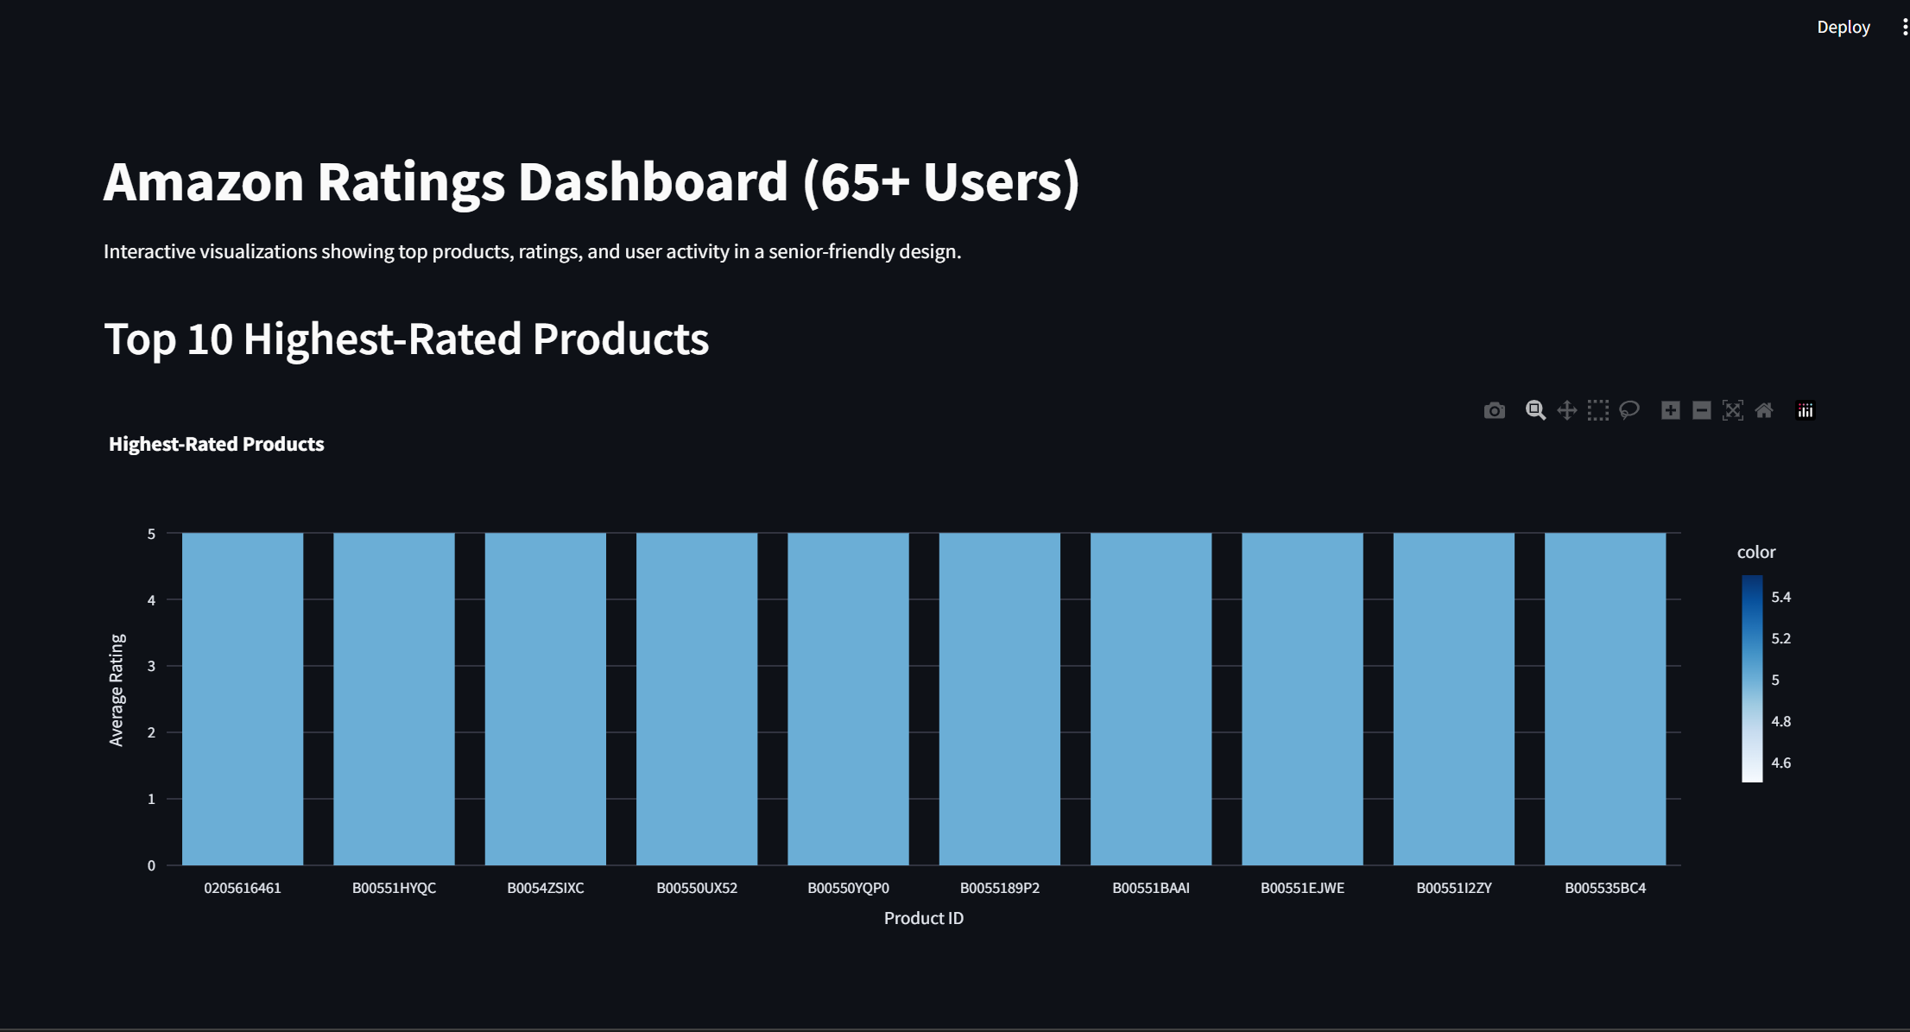
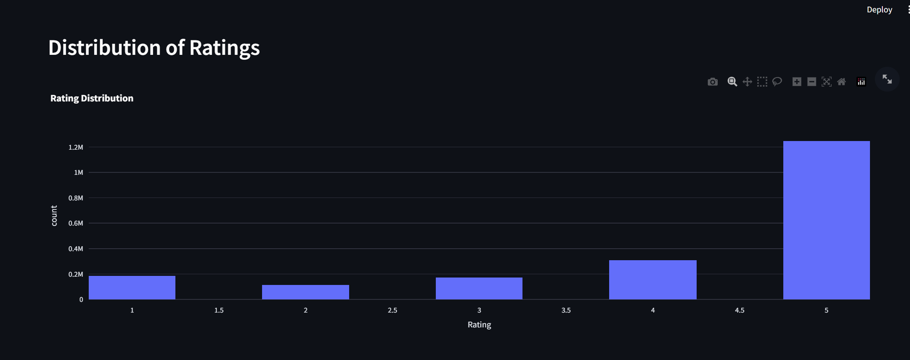
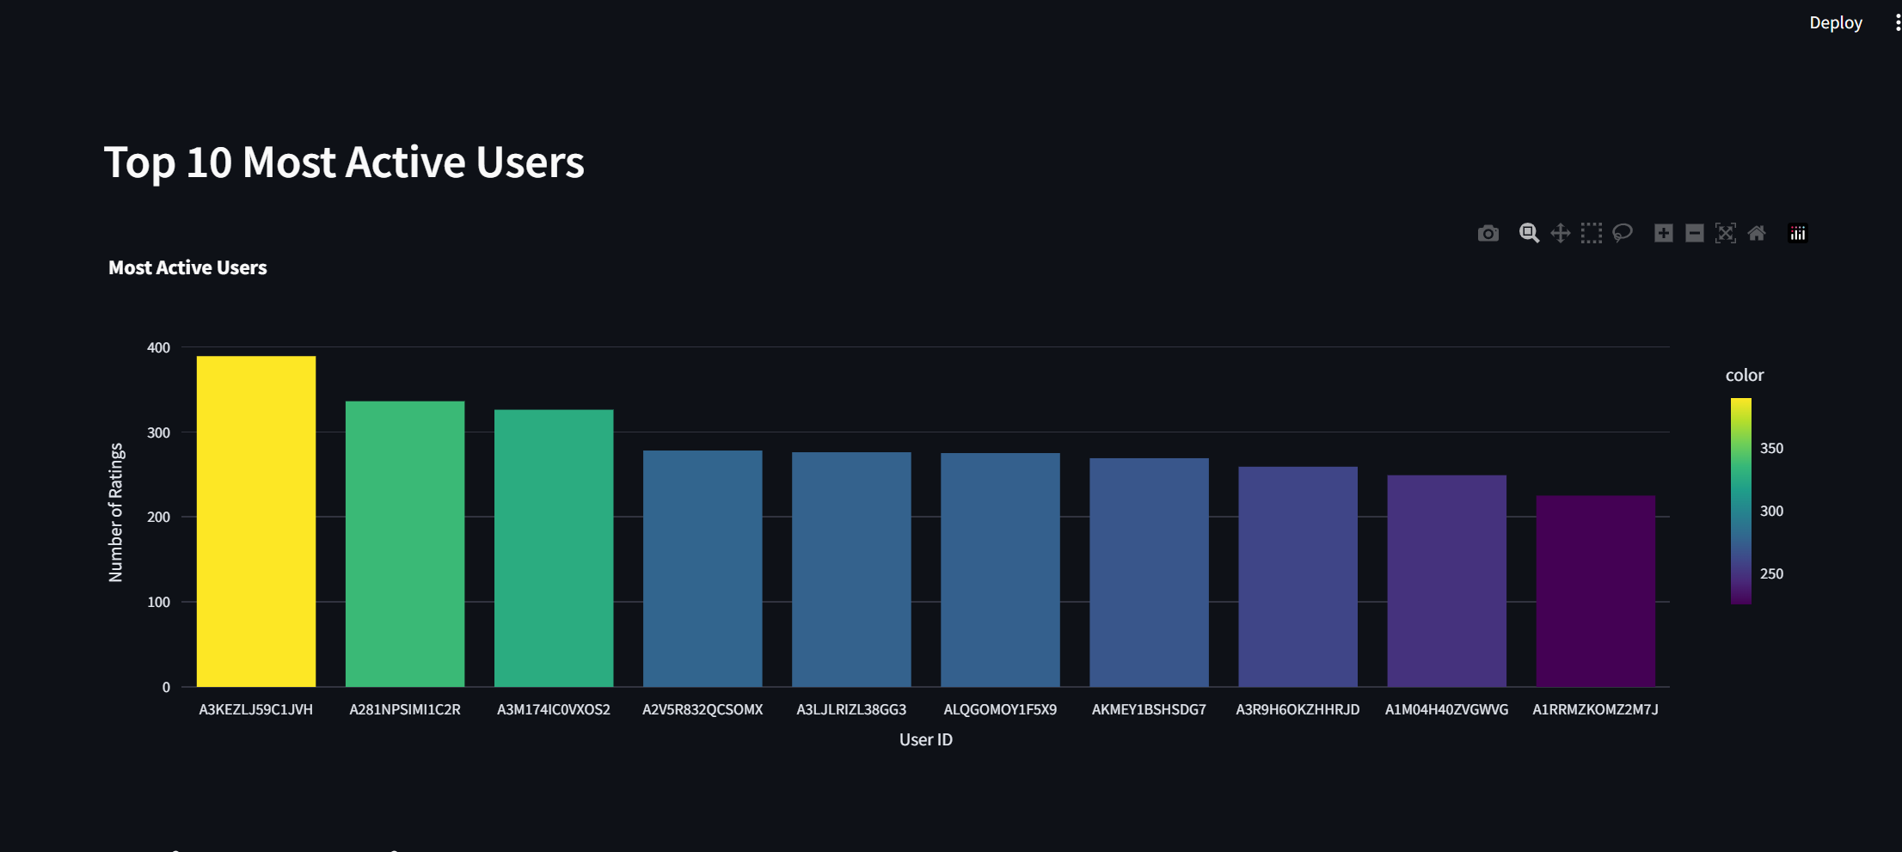
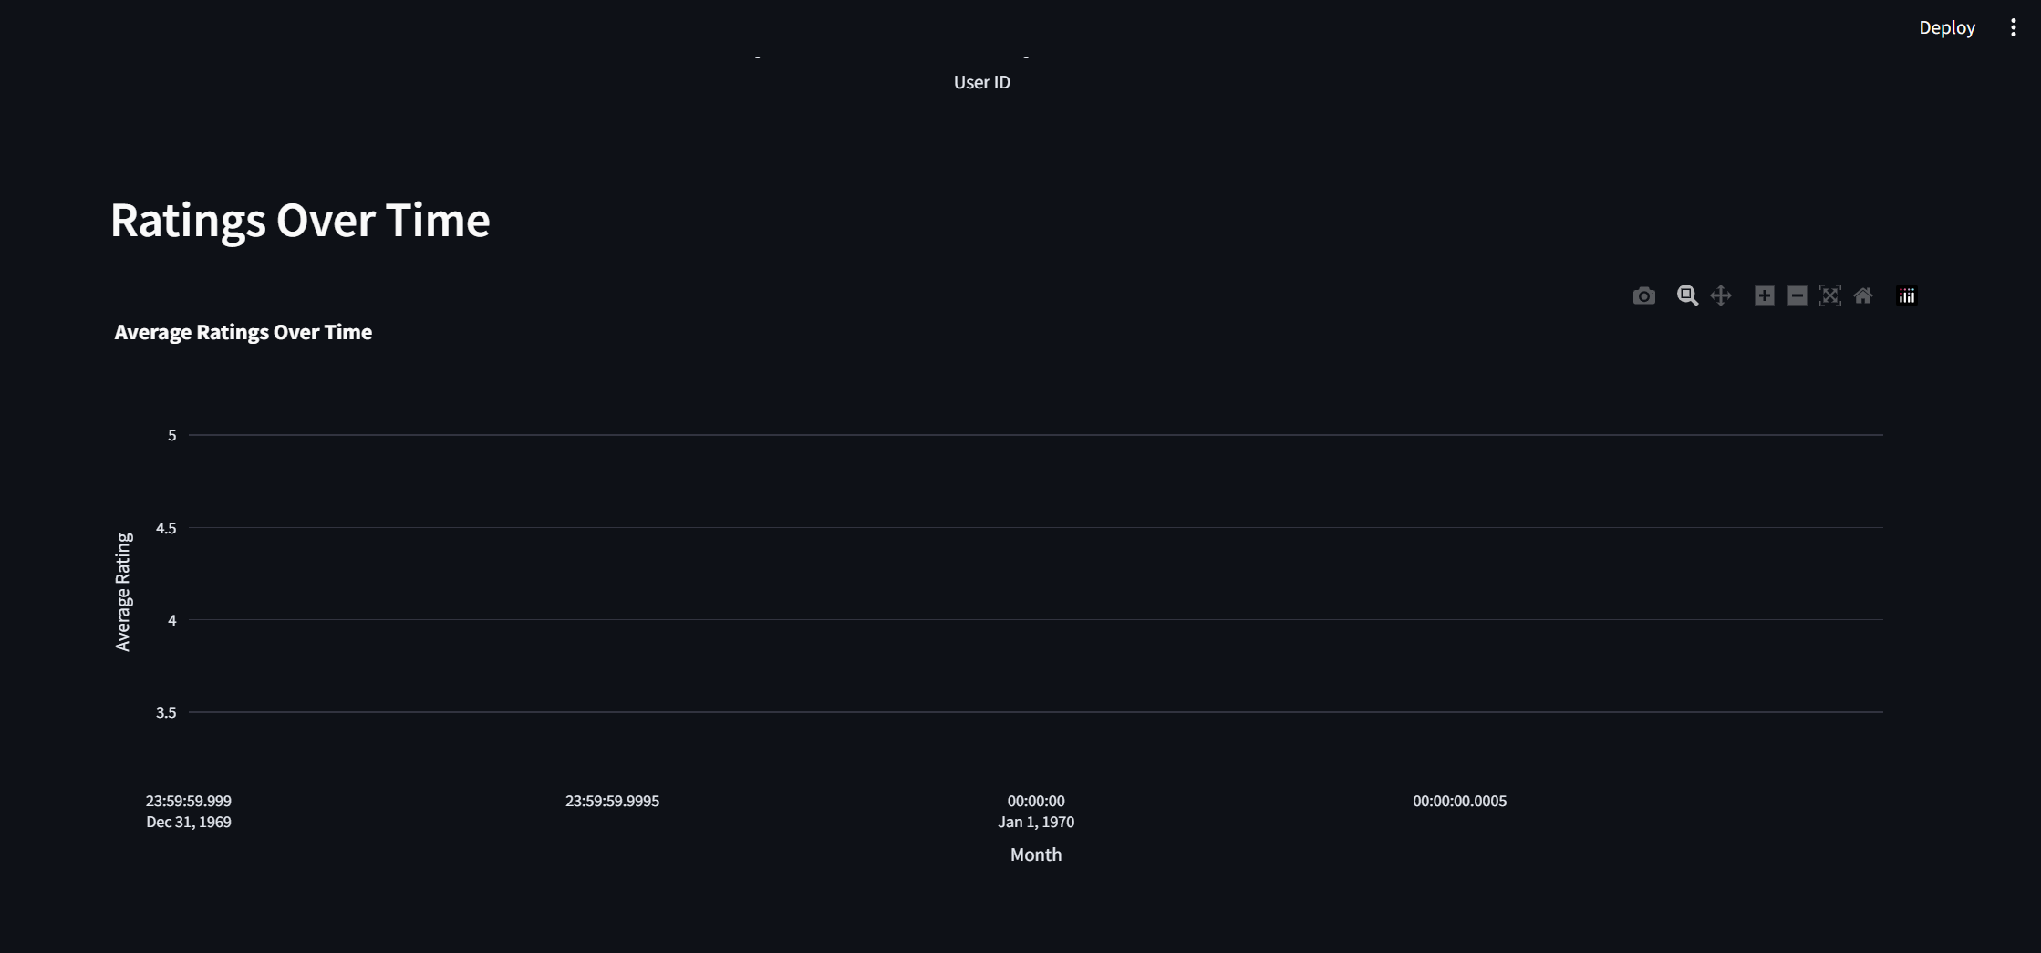
The Amazon “Ratings_Beauty” dataset was used to demonstrate collaborative filtering recommendation systems. The Streamlit dashboard included:
- User-item recommendations: A display of recommended products for selected users, showing the predictive power of collaborative filtering models.
- Interactive selection: Users could select a specific user ID to view personalized recommendations, demonstrating how machine learning can enhance shopping experiences.
The design prioritized simplicity, clear labels, and large fonts, making it easier for older users to interpret personalized recommendations without cognitive overload (Charness & Boot, 2016).
Suitability for Machine Learning:
Both dashboards show why the datasets are suitable for machine learning in retail: the Bakery dataset supports association rule mining and Market Basket Analysis, while the Amazon dataset supports collaborative filtering. Visualizing these results helps business stakeholders and users alike understand patterns, trends, and model outputs, reinforcing the value of machine learning in enhancing customer experience and decision-making (Aggarwal, 2021; Han et al., 2018).
Design for Older Adults:
All visualizations incorporated accessibility principles: readable fonts, contrasting colors, minimal clutter, and interactive but simple elements. These choices reduce cognitive strain, improve engagement, and make insights actionable for the intended demographic (Fisk et al., 2020).

To access the dashboards, these are the links:
http://localhost:8501/ - Bakery Dataset
http://127.0.0.1:8050/ - Amazon dataset

Question 4: Rationale and Justification for Data Preparation
Data preparation is a critical step in any data analysis or machine learning project. Proper cleaning, transformation, and structuring of data ensures that models can accurately capture patterns and insights while minimizing errors (Han, Kamber and Pei, 2018). In this project, each dataset underwent specific preparation steps tailored to the analysis techniques and visualizations being used.
1. Bakery Dataset:
The Bakery dataset consisted of columns: TransactionNo, Items, DateTime, DayPart, and DayType. Initially, the dataset was checked for missing values and duplicates. Although there were no missing values, 1,620 duplicate rows were identified and dropped. Removing duplicates prevents artificial inflation of support counts in Market Basket Analysis and avoids biasing the results, particularly since duplicates represented a very small fraction of the total data (Fayyad et al., 1996).
Next, the Items column, which originally stored comma-separated strings, was split into lists to represent individual transactions. This step is necessary for transaction-based algorithms such as Apriori and FP-Growth, which operate on sets of items purchased together (Han, Kamber and Pei, 2018). Transactions were then grouped by TransactionNo, creating a list of items per transaction, and one-hot encoding was applied. One-hot encoding converts categorical item data into a binary matrix, enabling the Apriori and FP-Growth algorithms to efficiently compute frequent itemsets and association rules. Without this step, the algorithms would not interpret the item presence correctly.
2. Amazon Dataset (Ratings_Beauty):
The Amazon dataset included UserId, ProductId, Rating, and Timestamp. All columns were verified for missing values, which could cause errors in collaborative filtering calculations. To prepare the data for user-user and item-item collaborative filtering, the UserId and ProductId columns were transformed into categorical codes and then used to construct a sparse matrix. Sparse matrices are ideal for large-scale recommendation datasets because they efficiently store and process only the non-zero ratings, saving both memory and computational resources (Aggarwal, 2021). This data structure allows nearest-neighbor algorithms to compute similarities between users or items effectively, even when the dataset is highly sparse.
3. Anime Dataset (Content-Based Filtering):
For content-based recommendations, textual data needed to be transformed into numerical features. The Description and Tags columns were combined into a single desc_blob for each anime. TF-IDF vectorization was applied to convert these text descriptions into numerical feature vectors. TF-IDF assigns higher weights to unique and informative words, allowing cosine similarity to measure how closely two anime items are related based on content (Manning, Raghavan and Schütze, 2018). Without this step, it would be impossible for the algorithm to quantify textual similarity between items.
4. Dashboard Preparation for Older Adults (65+):
For both dashboards (Bakery using Dash and Amazon using Streamlit), the data had to be structured to support interactive visualization. Key metrics such as top products, co-purchase rules, transaction distribution, and user-item recommendations were extracted and aggregated. Visualization choices were made based on accessibility principles: large fonts, high-contrast color schemes, minimal clutter, and interactive elements (Lazar et al., 2017; Charness and Boot, 2016). These choices ensure that older users can easily interpret charts, tables, and recommendations without cognitive overload.
Justification of Steps:
- One-hot encoding in Bakery supports transaction-based machine learning.
- Sparse matrices in Amazon support scalable collaborative filtering.
- TF-IDF vectorization in Anime converts textual content into numerical features suitable for similarity calculations.
- Aggregation of metrics and visual simplifications enable older adults to interact with dashboards effectively.

References
Amazon Science (2023) Recommendations: Driving Personalisation at Scale. Available at: https://www.amazon.science (Accessed: 2025).
Gómez-Uribe, C.A. & Hunt, N. (2016) ‘The Netflix Recommender System: Algorithms, Business Value, and Innovation’, ACM Transactions on Management Information Systems, 6(4), pp. 1–19.
Ricci, F., Rokach, L. & Shapira, B. (2015) Recommender Systems Handbook. Springer.
Zhang, S., Yao, L., Sun, A. & Tay, Y. (2019) ‘Deep Learning Based Recommender Systems: A Survey and New Perspectives’, ACM Computing Surveys, 52(1), pp. 1-38.
Han, J., Pei, J. and Kamber, M. (2018) Data Mining: Concepts and Techniques. 4th edn. Morgan Kaufmann.
Aggarwal, C.C. (2021) Recommender Systems: The Textbook. Springer.

Schafer, J.B., Frankowski, D., Herlocker, J., & Sen, S. (2015) ‘Collaborative filtering recommender systems’, The Adaptive Web, Springer, pp. 291-324.
Ricci, F., Rokach, L. and Shapira, B. (2015) Recommender Systems Handbook. Springer.
He, X., Liao, L., Zhang, H., Nie, L., Hu, X. and Chua, T.S. (2017) ‘Neural Collaborative Filtering’, Proceedings of the 26th International Conference on World Wide Web, pp.173-182.
Lops, P., de Gemmis, M. and Semeraro, G. (2011) ‘Content-based Recommender Systems: State of the Art and Trends’, in Ricci, F. et al. (eds.) Recommender Systems Handbook. Springer, pp. 73-105.
Su, X. and Khoshgoftaar, T. (2009) ‘A Survey of Collaborative Filtering Techniques’, Advances in Artificial Intelligence, 2009, pp. 1-19.
Agrawal, R. and Srikant, R. (1994) ‘Fast Algorithms for Mining Association Rules’, Proceedings of the 20th International Conference on Very Large Databases, pp. 487-499.
Han, J., Pei, J. and Kamber, M. (2018) Data Mining: Concepts and Techniques. 4th edn. Morgan Kaufmann.
Han, J., Pei, J. and Yin, Y. (2000) ‘Mining Frequent Patterns Without Candidate Generation’, Proceedings of the 2000 ACM SIGMOD International Conference on Management of Data, pp. 1-12.
Agrawal, R. & Srikant, R. (1994) ‘Fast algorithms for mining association rules’, Proceedings of the 20th International Conference on Very Large Data Bases (VLDB), pp. 487-499.
Han, J., Pei, J. & Yin, Y. (2000) ‘Mining frequent patterns without candidate generation’, Proceedings of the 2000 ACM SIGMOD International Conference on Management of Data, pp. 1-12.
Charness, N. and Boot, W.R., 2016. Designing for older adults: Principles and creative human factors approaches. CRC Press.
Fayyad, U., Piatetsky-Shapiro, G. and Smyth, P., 1996. From data mining to knowledge discovery in databases. AI Magazine, 17(3), pp.37-54.
Han, J., Kamber, M. and Pei, J., 2018. Data Mining: Concepts and Techniques. 4th ed. Morgan Kaufmann.
Lazar, J., Feng, J.H. and Hochheiser, H., 2017. Research Methods in Human-Computer Interaction. 2nd ed. Morgan Kaufmann.
Manning, C.D., Raghavan, P. and Schütze, H., 2018. Introduction to Information Retrieval. 2nd ed. Cambridge: Cambridge University Press.

